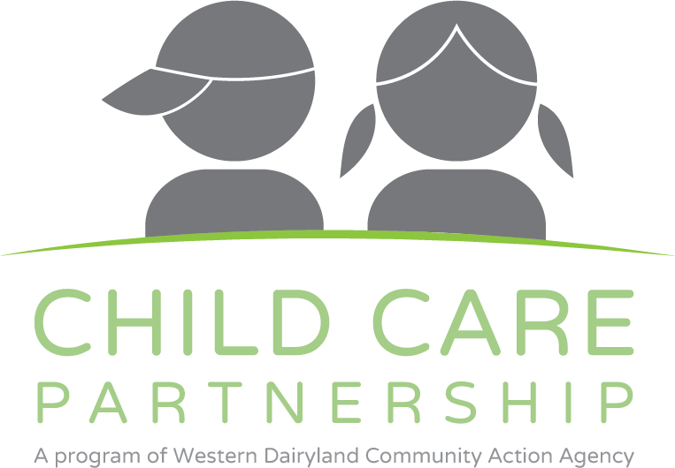

Child and Adult Care Food Program

418 Wisconsin Street, Eau Claire, WI 54703

P (800)782-1880 (715)831-17001

www.childcarefoodprogram.org

\
August 2017 Provider Update

CACFP HIRING

Reimbursement Dates

We are in the process of hiring a new monitor for the CACFP. When this position has been filled, our new staff will begin accompanying us on CACFP Visits. Look for their name and provider area in the coming weeks!
Please make sure your calendars are up to date and/or you contact the office when you plan to be away. This will assist in completing home visits quickly and efficiently and avoid your monitor needing to visit more than once.
We thank you for continuing to be patient with us while we fill this position!

Reimbursement for July 2017 claims will be deposited on September 1st, 2017.
Reimbursement for LATE June 2017 claims will be deposited on September 8th, 2017.

At-Home Training

Meal Pattern Training
At home trainings will be mailed mid-August to providers who we know are not planning to attend an in person training. This mailing will include both the Annual Training requirement and the Meal Pattern Training overview.
More information to come.
Please contact our office with concerns or questions.
Our in-person Meal Pattern trainings are well under way. Trainings were completed in Onalaska and Viroqua during the end of June and in Siren, Rice Lake and New Richmond mid-July. Feedback from providers indicated they went well and the information was very helpful. If you have not yet registered for a Meal Pattern Training – please do! Dates are listed below.

August 17th, Lunda Community Center, 405 WI 54, Black River Falls, WI
August 28th, Best Western, 100 Spring Street, River Falls, 54022
September 6th, Western Dairyland, 418 Wisconsin Street, Eau Claire, WI

All trainings are scheduled from 6:30-8:00 PM and will provide 2 hours of continuing education. Monitors will be open to a Q & A session following the training if requested.

*Registration is not required, however if a training is not filled it does run the risk of being cancelled. Please register so we know to expect you!

Got Friends?

Do you know Family Child Care providers who are not currently benefiting from CACFP Participation*?
Have them call us! For each referral an existing WD provider sends our way between now and 12/31/18 they will be entered into a drawing for a great prize!
*Only applicable for providers who are not currently affiliated with a CACFP Sponsor.

KidKare
As of our July claim, we officially have all online claiming providers using KidKare! Yay! We hope the process went relatively smoothly, but please know we are here to support with any concerns you are having.
There are many useful videos available from KidKare and can be found at the address below:
https://help.kidkare.com/help
Please also note, that KidKare is a program supported by Minute Menu Systems so when you hear your monitor talk about Minute Menu – they are still involved in our claim process! Keep an eye out for upcoming enhancements from KidKare that will allow us to support the updated meal patterns beginning October 1st!

Need Help?
If you don’t find what you need on our website, please call us! We are always available to help you!
Contact us at (800)782-1880 or cacfp@wdeoc.org

Do you read me?

If you made it this far in our newsletter; send an email, Facebook message or tell your monitor you read it all! You will be entered into a prize drawing to be awarded during your 1st home visit of FY2018!



